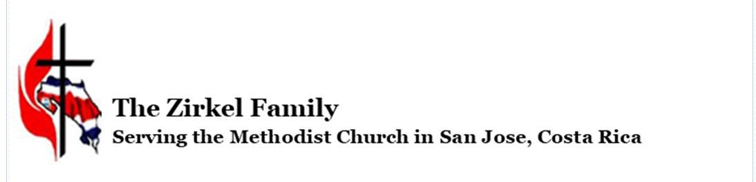

October has been filled with excitement!
During the month, we welcomed two mission teams to the Children’s Home and a team to the Guapiles Methodist Church. One of our teen boys from the Children's Home was transferred to live with his older brother. Our sweet twin boys were reunited with their mother and shortly after their departure, we received a newborn baby boy (7days old). Last week, we welcomed an eight-year-old boy who is the older brother of two of our current children. Our homes and our hearts are full. We can’t wait to see what November will bring!
Recently, we celebrated Cultural Day at the Children’s Home school. The children in each grade level chose a specific country to highlight. Then they prepared food, dances, posters, and dressed in clothing appropriate to the country they represented. The visiting mission team from Dallas served as their audience. It was a perfect day!
The parsonage in Guapiles is coming along quite well. The walls are up and the floor has been poured. (Thanks to the recent mission team from Atlanta!) The windows will soon be installed along with the exterior doors. Our hope is to have pastor Daniel and his family in their new home by the end of the year even if a few external details remain for 2023. If you or your church would like to come and help with the ministry in Guapiles (sanctuary), Puerto Viejo, Limon, or at the Children’s Home, please contact us. We have begun signing up mission teams for the coming year and would love to have you!
The Methodist Seminary has been making plans to return to “in person” classes for 2023. After teaching online for two and a half years, Ray could not be happier with the anticipated change; teaching to a screen is not his favorite! This week he is wrapping up the final lessons on his Church History course to over 40 students.
Following a two-year delay, the Methodist School reinitiated its week-long senior class camp at the end of September. This year, fifty-five students and ten teachers were welcomed to the beautiful grounds of Camp Eagle in Rocksprings, Texas. The week was filled with Bible studies, (special thanks to Pastor Ryan Barnett) worship services, small groups and lots of opportunities for team building. One of the favorite games at camp is archery tag; and given that Ray is so competitive when he plays with the students and teachers, they actually had a special shirt made for him!
We are most grateful to each of you for your continued prayer and financial support of us and our ministry. We could not minister to the lovely people of Costa Rica without your help. Thank you!
“In all my prayers for all of you, I always pray with joy because of your partnership in the gospel from the first day until now, being confident of this, that he who began a good work in you will carry it on to completion until the day of Christ Jesus.” Phil. 1:4-6
Blessings,
Ray and Lidia
